The Cuckoo's Nest Presents

Who tells your Story?
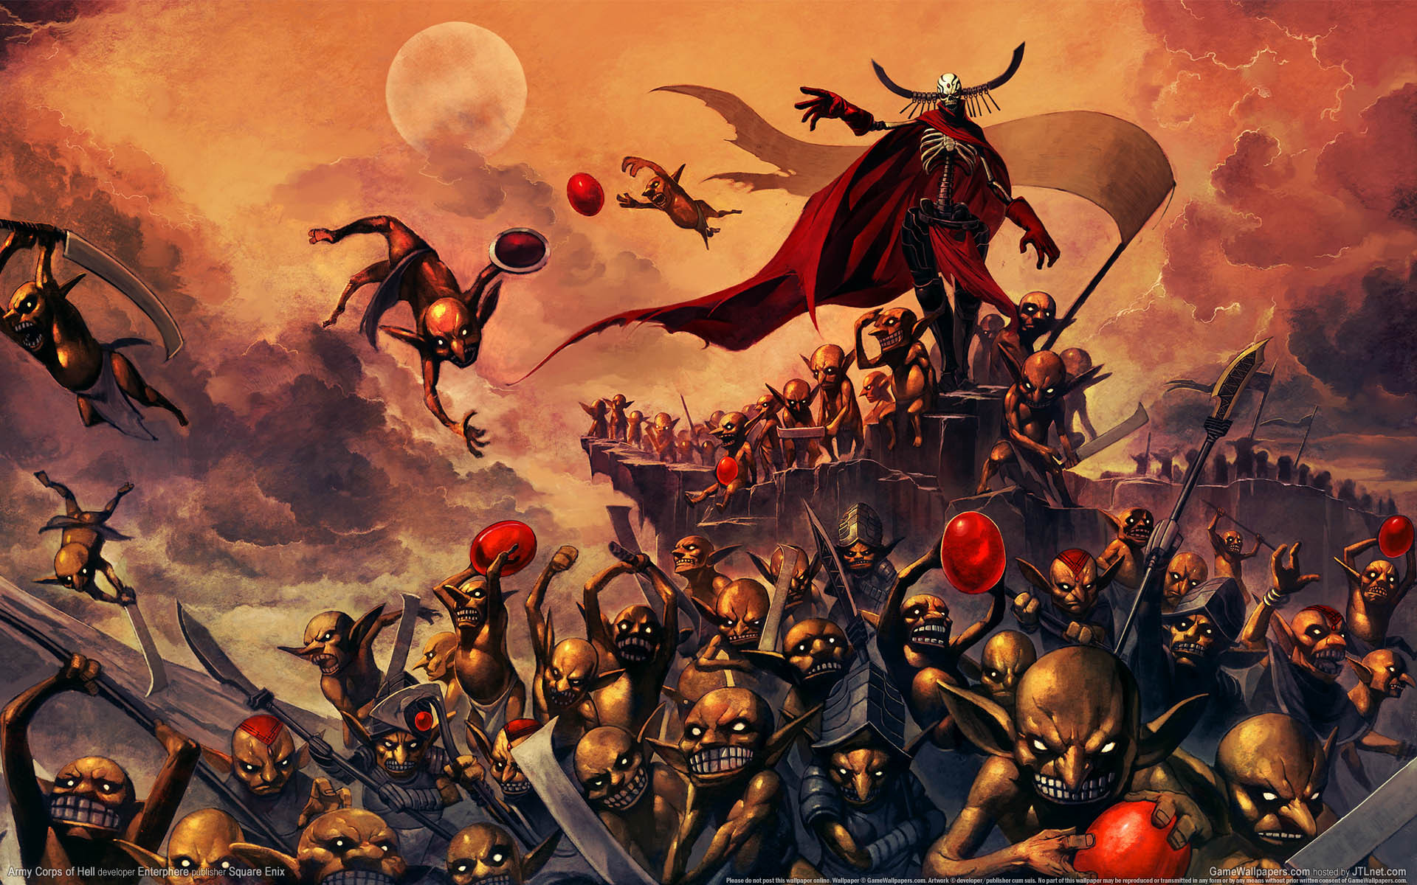
Fae and demon cultists alike are converging on the breach at Oracle Mount and the activity has also drawn the attention of the Ocelotopec, the ruthless tribesfolk in the North.
There are two dire warnings that lead to this place and this moment: One carried from the future, warning of the destruction of the Accord by The Dragon Prince, Serpenterra. One gleaned from the Stones of Atain, that the Demons of Vakivalta seek to free themselves from their prison by exchanging places with captured Guardian souls.
Castann, once again, finds itself on the battlelines, however there is little more hardship the once proud nation can take.
The Wardens have made camp near the base of Oracle Mount, joined by the Knights of Camelot and the followers of Clymenia, Tawhaki and Aotahi who have continued to hold the breach for nearly a year.
The Remembered and the Gifted of Dasura are also present but camped elsewhere to ease bubbling internal tensions within the alliance.
The orders are simple: Protect the Accord at all costs. Can the Wardens of the Accord avert two dire prophecies? Will the alliance survive the battle or collapse before the battle horns sound?

Who will live to tell the Story?

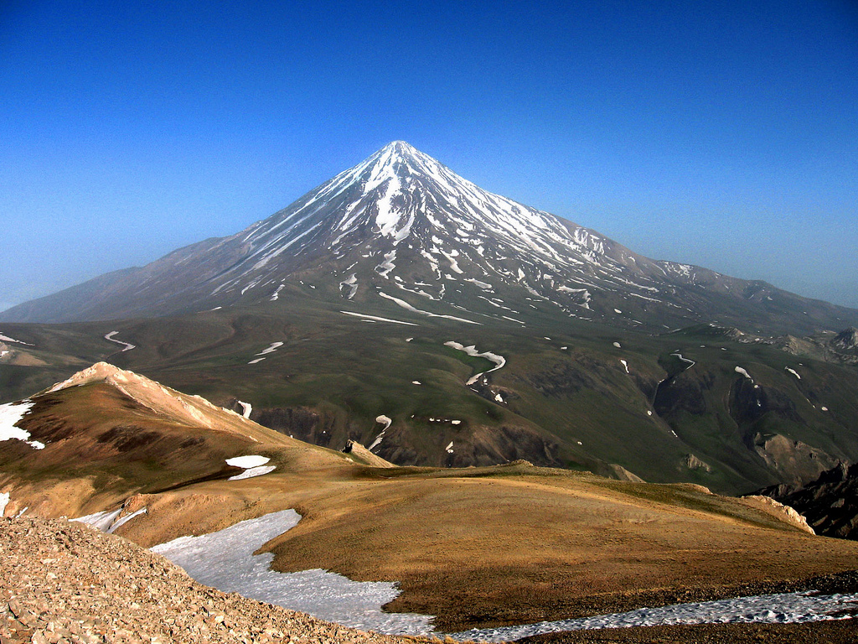

Ratlingate Scout Camping Centre
Ratlingate Lane
Nr. Kirkandrews-on-Eden
Carlisle
CA5 6DW

Friday 5th April 2019
17.00 - Players may arrive on site

19.00 – Time in called
Evening/Night Adventures

Saturday 6th April 2019

Daytime Adventures
Evening Banquet
Night Adventures

Sunday 7th April 2019
Morning Finale
14.00 Tidying
16.00 Off-site

This is a mainly Play Event; Volunteering to monster for portions of the day will allow us to put on a better event and although expected is not mandatory. Spare IC equipment, IC money and other items brought must be phys-repped. You may wish to bring banqueting clothes, a set time shall be non-combat, but other plot might still happen. Dark/neutral monster kit would be recommended as well as your normal Character Kit.

Accommodation, Facilities and Feeding

- This is an indoor camping event. Bunks are available for all, but facilities are limited.
- Food will be catered for internally
- A Banquet is included with every Player Place. Numbers will be needed before the event secured with a deposit.
- Shower Facilities are available!

Resistance Banquet Spring 2019 Booking Form
Friday 5th April to Sunday 7th April 2019

Out of Character information
My Name
Email
Contact Phone
Car Registration
Emergency Contact Name
Emergency Contact Number
Special Dietary Requirements
Medical Conditions ¹
¹ Let us know about anything that you think may affect your health or safety, or that of others, while you are at the event. We will of course keep this information confidential.
In Character Information

Name
Race
Nationality
Religious persuasion
Magic items
Active Curses/Blessings
Any other information

Payment & Booking Instructions
- Please complete one form for every Player/Monster Place you require.
- You can Print and save this. If you prefer, save and email it to nestlarp@gmail.com
- A player space is £50. A monster/crew space is £10
- You can pay in cash or send payment by PayPal to nestlarp@gmail.com. Please use a separate PayPal transaction for each Player/Monster Place. Don't forget to include your name as a reference so we can match your payment up with your Booking Form. Payments can be made in instalments by arrangement.
- Please include a recent copy of your character sheet and any pertinent background details.

Booking Conditions

- Your place is only confirmed once a completed Booking Form and Payment have been received by The Nest Committee and receipt acknowledged.

- Once a Player Place has been booked, we will not normally reimburse any fees in the event of a cancellation on your part.

